**CONCEPTS OF ETHICAL HACKING LAB**

**WEEK – 3**

**PHISING ATTACK**

The practise of sending fraudulent communications that appear to come from a reputable source. Usually done through email. An art of psychological manipulation to deceive people into reveling sensitive information.

**Requirements :**

1.VM Ware

2.Linux

3.ZPhisher

4.CloudFare

**Procedure :**

1. Open VMWare and create kali linux and setup it.
2. Open root terminal and clone github ZPhisher respositories.
3. Open zphisher tool and install all requirements.
4. Follow the process :
5. git clone <https://github.com/htr-tech/zphisher>
6. 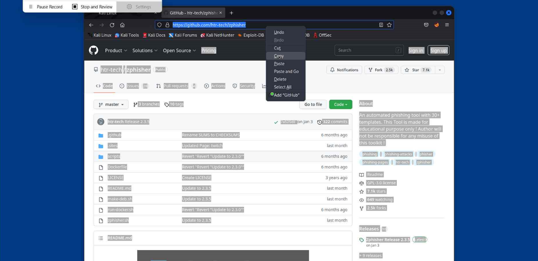
7. cd zphisher
8. bash zphisher.sh
9. 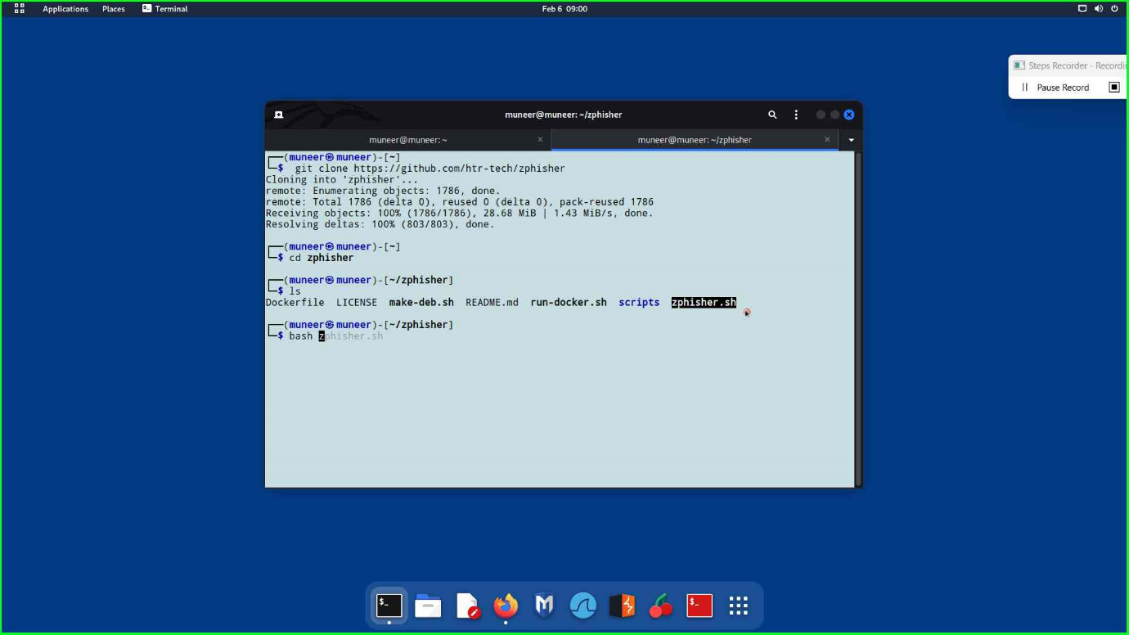
10. Selection of desired page from displayed pages.
11. 1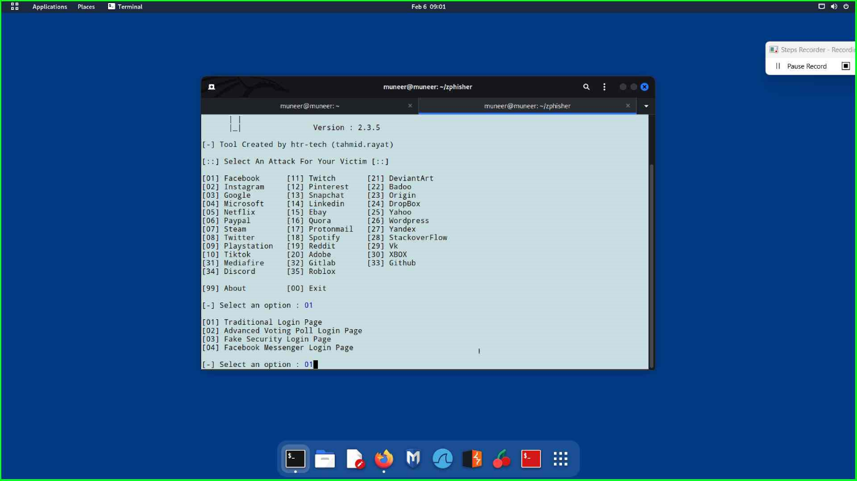
12. Select the hosting tunnel such as ngrock, cloudFare and etc.
13. 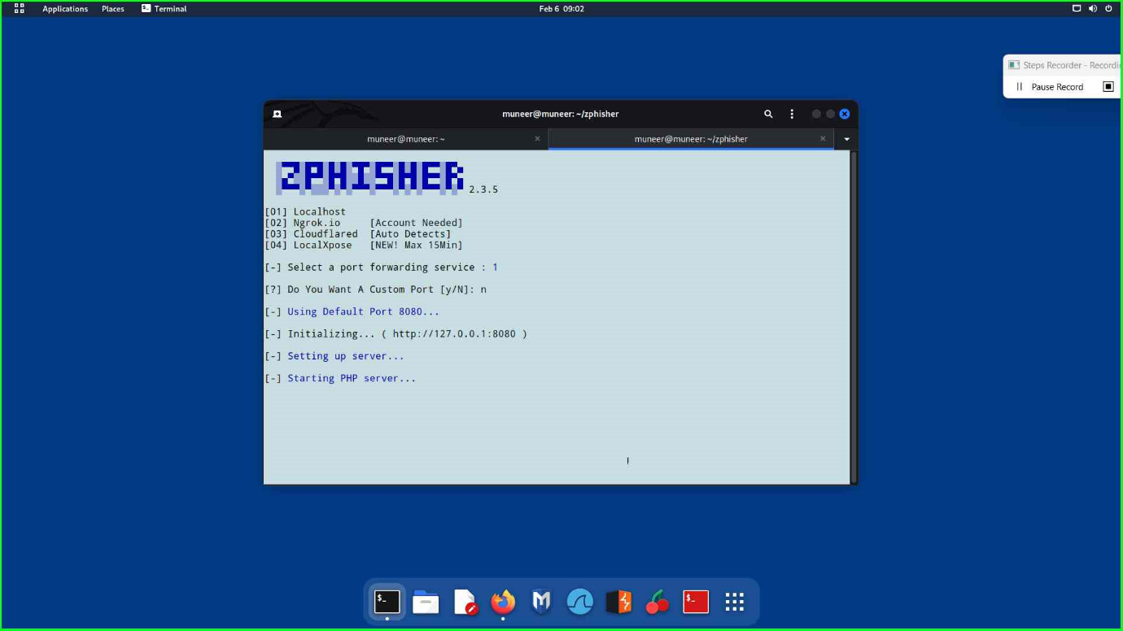
14. Link will be displayed and forward it to a victim.
15. 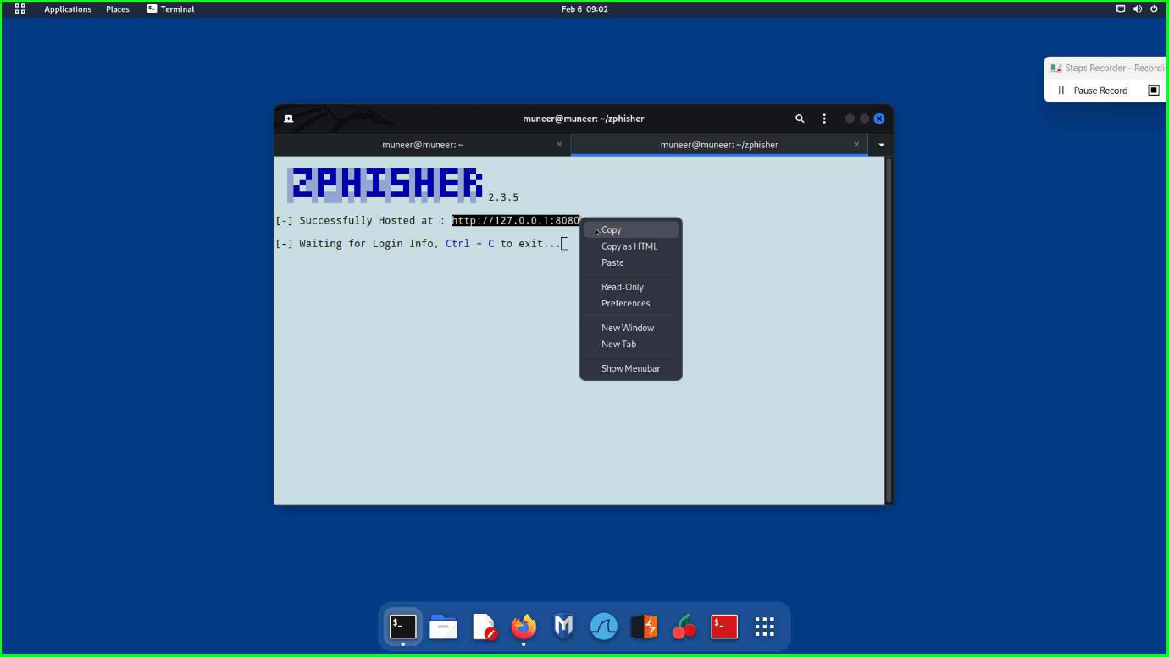
16. Output:
17. 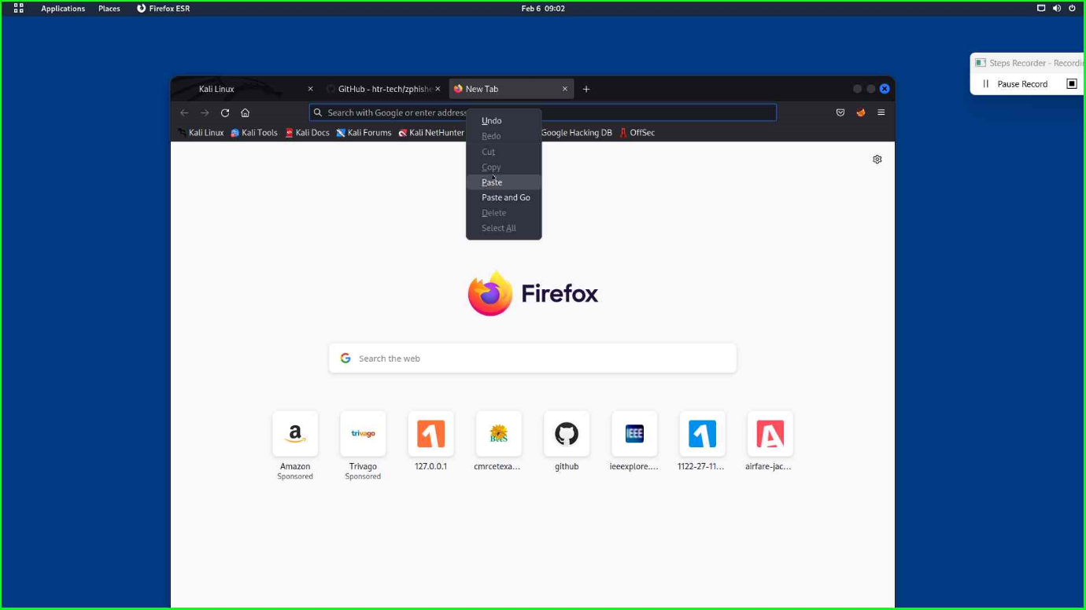

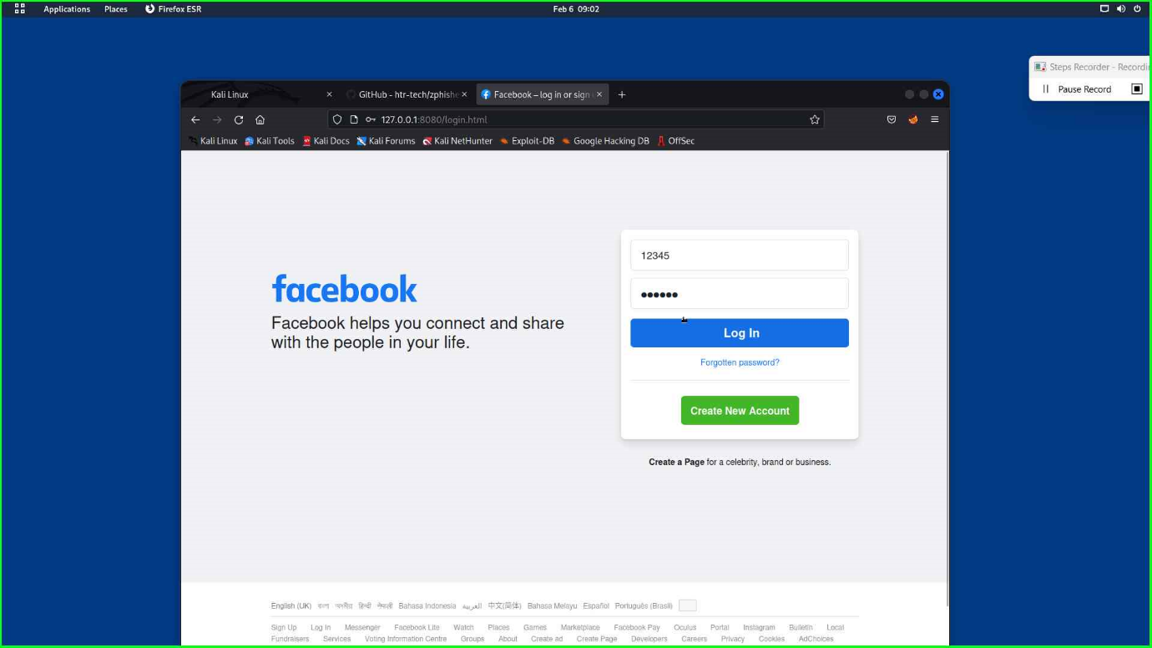

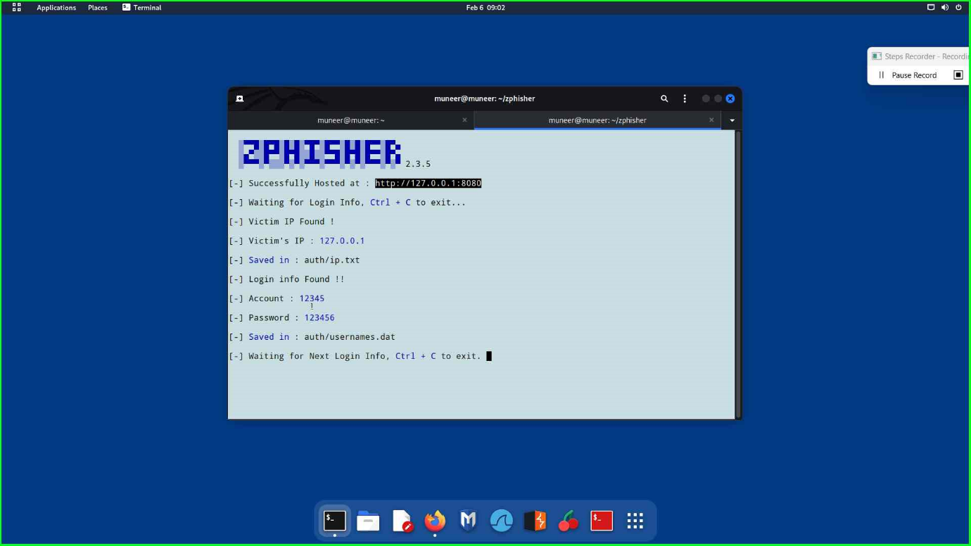

----END---